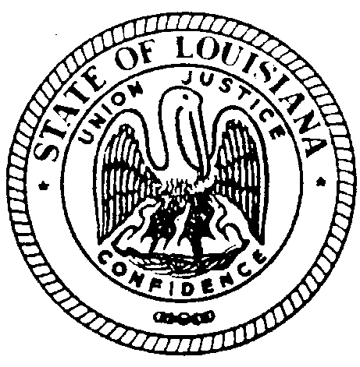

STATE OF LOUISIANA
LOUISIANA BOARD FOR HEARING AID DEALERS
308 Gregory Dr. Luling, LA 70070 E-Mail- labhad@la.gov Voice/Text: (504) 655-0383

BOARD MEETING

DATE: SATURDAY JUNE 8, 2019

TIME: 9:00 AM

LOCATION: EMBASSY SUITES
4914 CONSTITUTION AVENUE
BATON ROUGE LA 70808

The Louisiana Board for Hearing Aid Dealers meeting will be held
June 8, 2019 @ Embassy Suites in Baton Rouge board room beginning 9:00AM. This meeting is open to the public.

Submitted on behalf of The Louisiana State Board for Hearing Aid Dealers by:

Dina Zeevi
Administrative Secretary
Louisiana Board for Hearing Aid Dealers
(504)655-0383
labhad@la.gov

